**F1TENTH Power Distribution Board Data Sheet**

Version 9.0

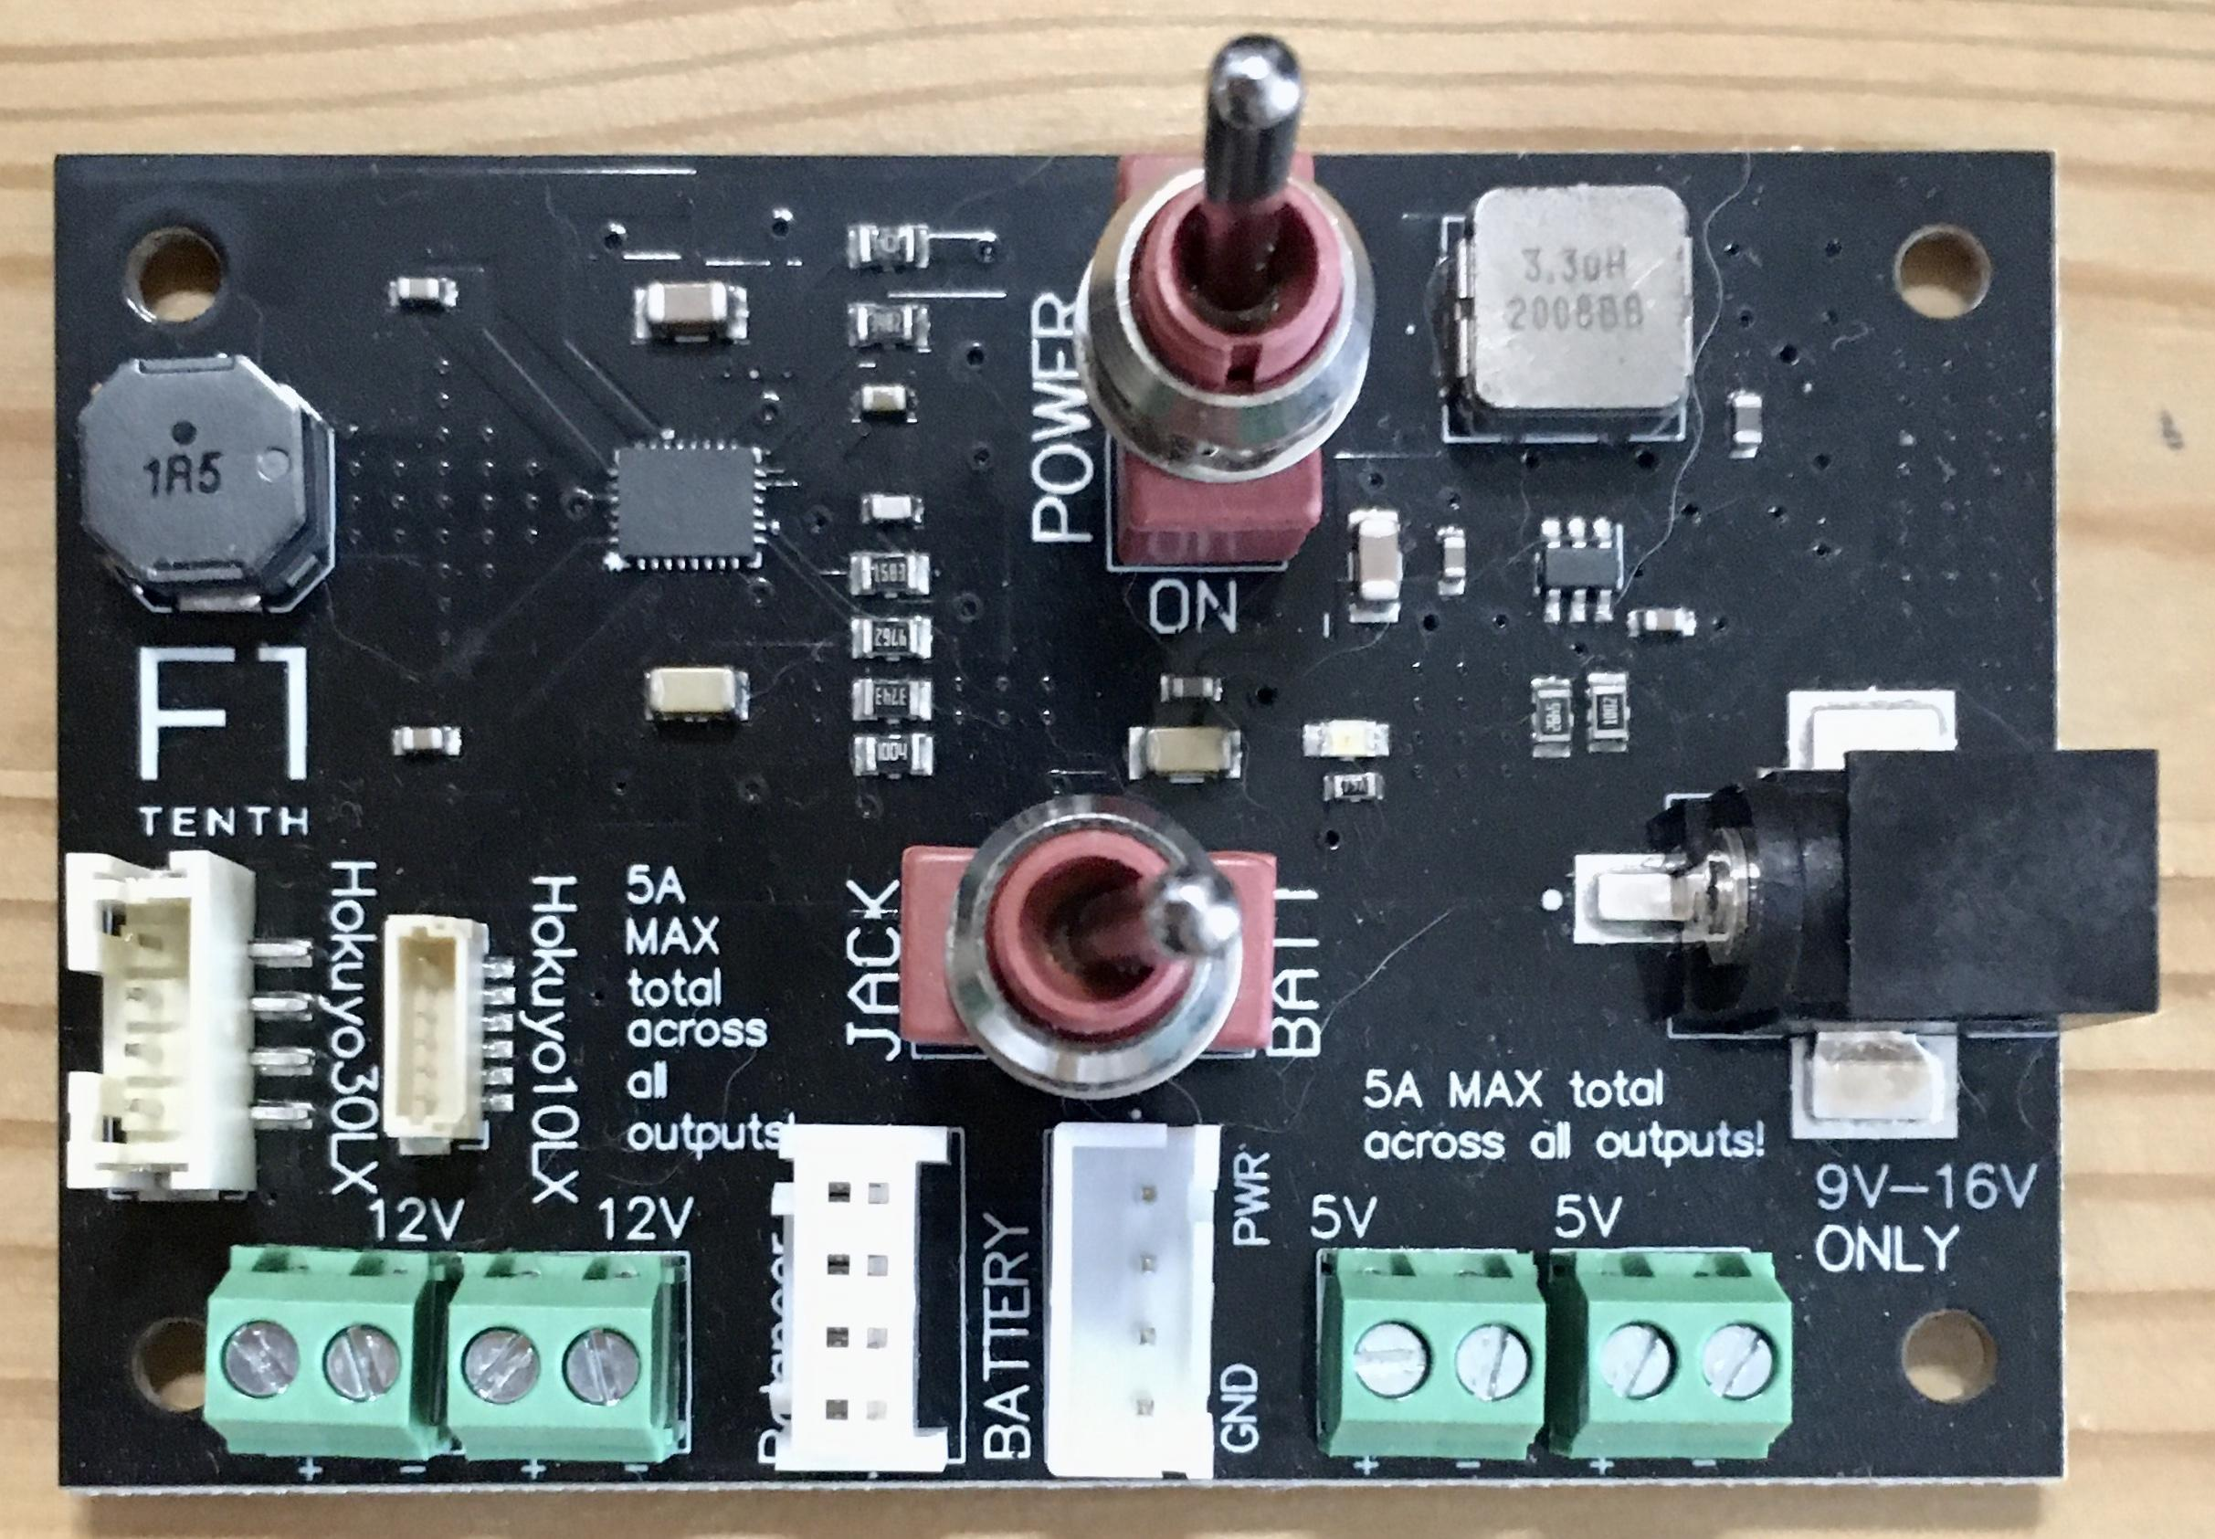

**Table of Contents**

DISCLAIMER **2**

PRODUCT DESCRIPTION **2**

TECHNICAL SPECIFICATIONS **2**

ADDITIONAL HELP **2**

BLOCK DIAGRAM **3**

BARREL JACK SPECIFICATION **3**

POWER OUTPUTS **4**

COMPONENTS **4**

SCHEMATICS **4**

ASSEMBLY AND MANUFACTURING **5**

SIDE VIEW **6**

MECHANICAL SPECIFICATIONS **6**

# DISCLAIMER

The F1TENTH team is not liable for any accidents that result due to improper use of the power distribution board. Read through this entire document carefully before proceeding.

# PRODUCT DESCRIPTION

This is the power distribution board for the [F1TENTH](https://f1tenth.org/) autonomous vehicles. It is a four-layer printed circuit board that takes in the voltage of a 3 cell lithium polymer battery and outputs 5V and 12V via a buck converter and a buck-boost converter. There are two 12V JST headers available for connection with the LIDARs.

All of the relevant files can be found [here](https://drive.google.com/drive/u/1/folders/1paAAmrVMGlvhv1ywrn51DmMieW0aIarS).

# TECHNICAL SPECIFICATIONS

| **Electrical Input** | |
| --- | --- |
| Battery | 3S, 11.1V LiPo |
| Barrel Jack (2.5x5.5mm) | 9.0-16.0V |
| **Electrical Output** | |
| Maximum Total Current Output | 5A |
| Terminal Blocks (3.50mm) x2 | 5V |
| Terminal Blocks (3.50mm) x2 | 12V |
| B4B-PH-SM4-TB Connector | 2A, 12V |
| BM06B-SRSS-TB Connector | 1A, 12V |
| **Mechanical** | |
| Size (mm, W x L x T) | 75.3 x 50.3 x 1.6 |

# ADDITIONAL HELP

Post on the [forum](https://f1tenth.org/forum.html) if you have any questions.

# BLOCK DIAGRAM

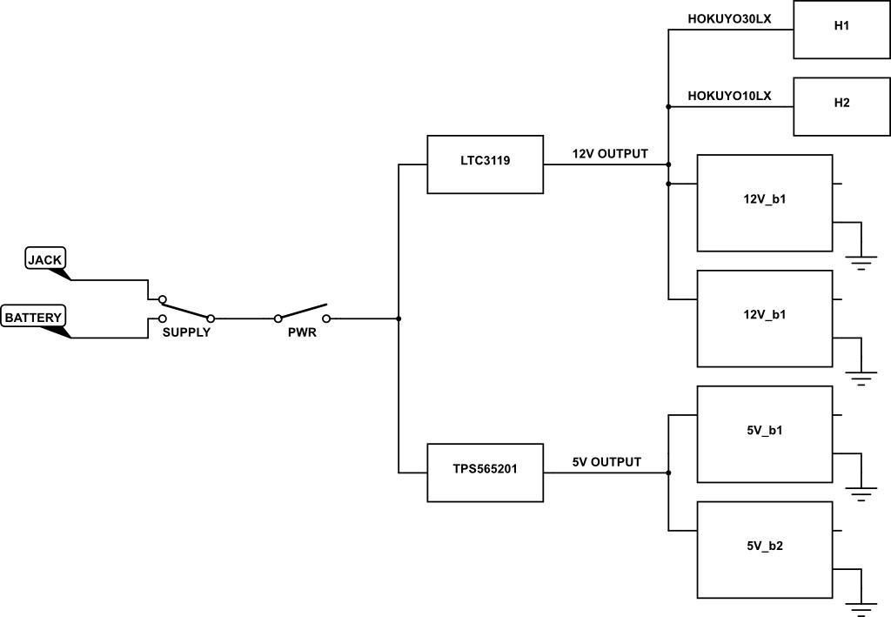

# BARREL JACK SPECIFICATION

The board uses a 2.5x5.5mm [power jack](https://www.digikey.com/product-detail/en/cui-devices/PJ-036BH-SMT-TR/CP-036BHPJCT-ND/1530996) (MFN: PJ-036BH-SMT-TR). It is an unfortunate fact of life that the connections for barrel jacks are not standardized. For the specific barrel jack on this board, the center pin is **POWER**. Do not plug in a power supply whose center pin is ground. The schematic is shown below.

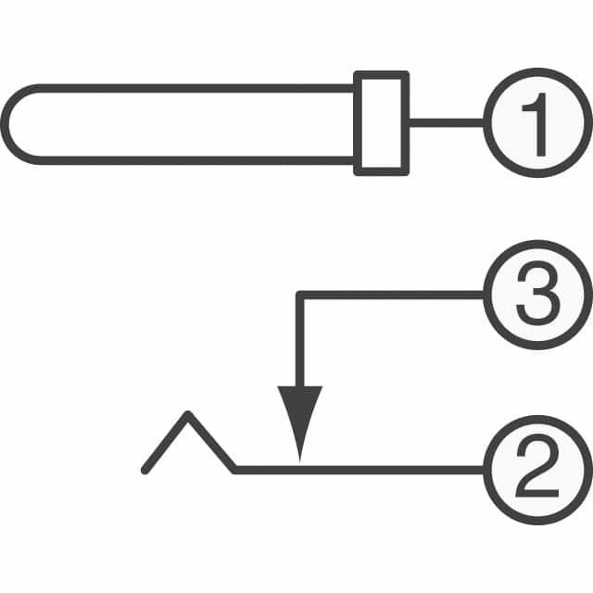

**Furthermore, the barrel jack is only rated for 9.0V - 16.0V. The power supplies of the TX2 and NX are 19V. Do not plug those in.**

# POWER OUTPUTS

There are 6 possible output connections:

* 4x Two-position wire to board terminal blocks with a pitch of 0.128” (3.50mm)
* 1x Six-position SH series JST header
* 1x Four-position PH series JST header

There are two terminal blocks that can supply 5V and two that can supply 12V. Both of the JST headers supply 12V.

The PH series header can be used for the Hokuyo30LX LIDAR and the SH series header can be used for the Hokuyo10LX LIDAR.

If using the NVIDIA Xavier NX, a [jack/plug to pigtail](https://www.digikey.com/product-detail/en/tensility-international-corp/10-01779/839-1245-ND/5638255) is needed in order to connect the power supply of the NX to the terminal blocks on the power distribution board.

**Note that the *sum* of all output current must be less than or equal to 5A.**

# COMPONENTS

The bill of materials can be found [here](https://docs.google.com/spreadsheets/d/1ukOO_F29i1TCwMyt_XcXOZ6HkA_APXn1Cjo5-yl7PuI/edit#gid=1259443290). The board contains 37 components total comprising 29 surface mount parts and 8 through holes components. There are 33 unique components. The orange, purple, pink, and blue highlighted components are duplicates.

# SCHEMATICS

The schematic can be found [here](https://drive.google.com/file/d/1yr_snOrtbTv4ic9Su234A8S1jrcI2tVH/view?usp=sharing). There are three pages:

* TPS565201 Buck Converter
* LTC3119 Buck-Boost Converter
* Peripherals

If you have Altium, the project has been packaged with project packager (all files including libraries) and can be opened by extracting this [folder](https://drive.google.com/file/d/1tUrbjMxZ7ZGl8cn-xm2O472NJBSPIgPG/view?usp=sharing).

# ASSEMBLY AND MANUFACTURING

There are a few options on how to procure a complete power distribution board.

1. Request a power distribution board using [this form](https://forms.gle/eokyHHSmY18qQcJJA). As this is a beta run, the boards will be provided free of charge in exchange for feedback. There is a limited number of boards available so not all will requests will be accommodated.
2. DIY
   * It will take about 3-5 hours to solder for someone with previous surface mount soldering experience and about 8-10 hours for someone with less experience.
   * It is highly recommended that you test the power distribution board with a bench power supply prior to attaching the battery to ensure that there are no shorts.
   * During testing with a current controlled power supply, the following observations were noted:
     + With only the lidar plugged in, the current will spike to 1A before settling to ~0.4A.
     + The Jetson draws up to 0.4A before settling to ~0.2A
     + With all the peripherals attached (minus a monitor and keyboard attached to the USB hub), the board settles at ~1.7A.
     + When the monitor and keyboard are attached, the board settles at ~2A.
3. Order from a PCB manufacturer such as [pcbway](https://www.pcbway.com/) or [advanced circuits](http://www.4pcb.com)
   * You will need the following:
     1. [Gerber files](https://drive.google.com/file/d/1tUrbjMxZ7ZGl8cn-xm2O472NJBSPIgPG/view?usp=sharing)
     2. [Pick and place file](https://docs.google.com/document/d/1EgOW8CT0tZ8SQUHYSuxG4N2jCN8ZTkYDFiDprdFVqyw/edit?usp=sharing)
     3. [Part designator file](https://drive.google.com/file/d/1yh8_SFj1uHYGPGIeCuuawz4nRBG-mONC/view?usp=sharing)
     4. [Bill of Materials](https://docs.google.com/spreadsheets/d/1ukOO_F29i1TCwMyt_XcXOZ6HkA_APXn1Cjo5-yl7PuI/edit?usp=sharing)
   * Tip: During the manufacturing process, the manufacturer may contact you with a photo of an assembled pcb to confirm. Make sure that the slots of the battery header (B1) are facing to the right. See the image in the **SIDE VIEW** section as reference.

# SIDE VIEW

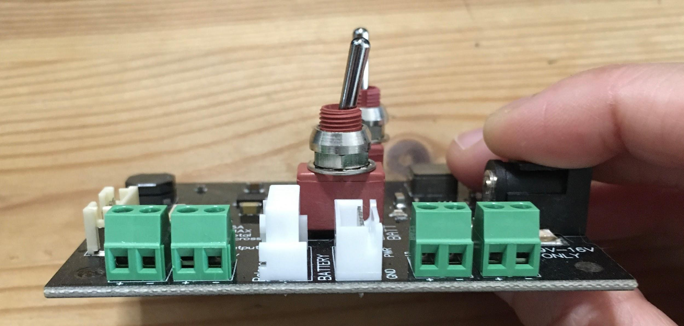

# MECHANICAL SPECIFICATIONS

All dimensions are in mm

